The critical path is shown in red:

1)
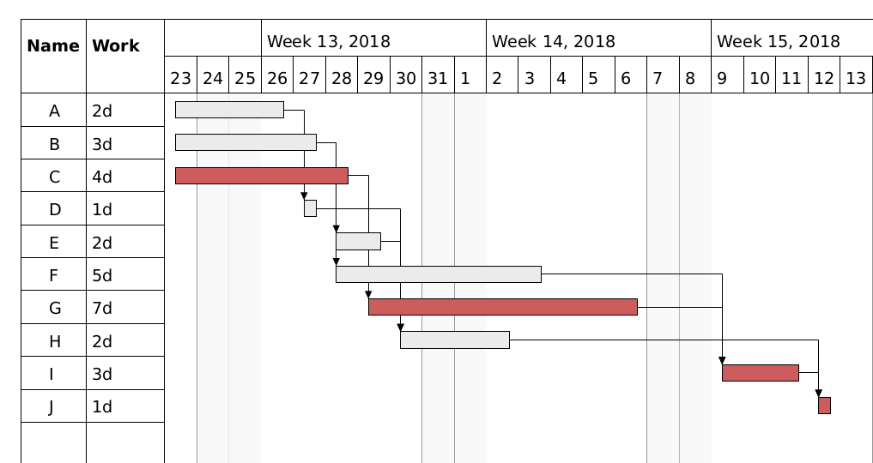
------------------------------------------------------------------------------------------------------------------------
2)
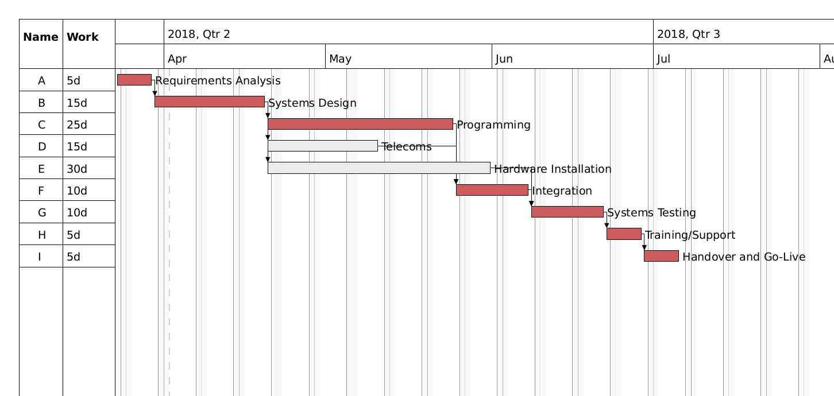
------------------------------------------------------------------------------------------------------------------------

3)
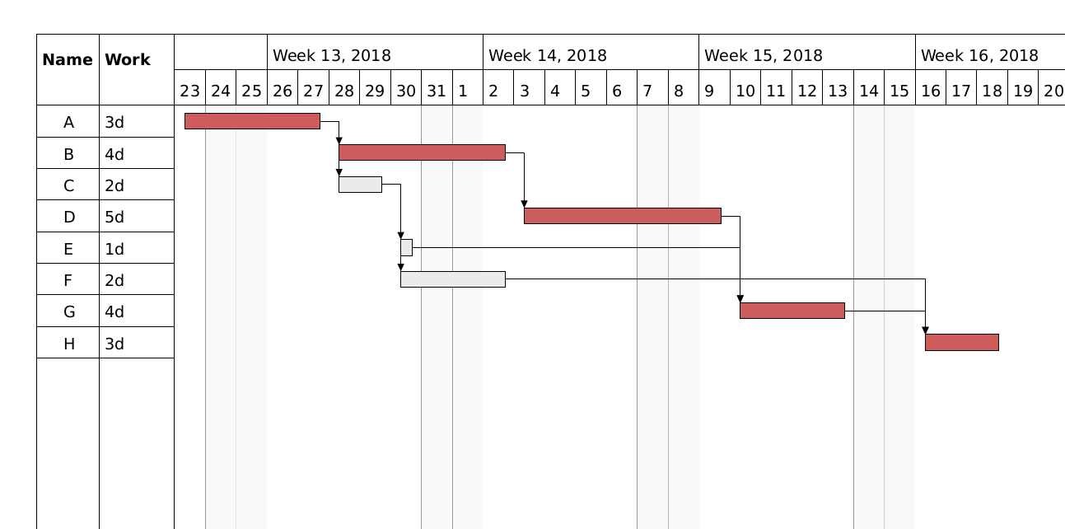
------------------------------------------------------------------------------------------------------------------------
4)



